Mini Project #7
Adam Blake Bell
April 5, 2017
Mini-Multiplier
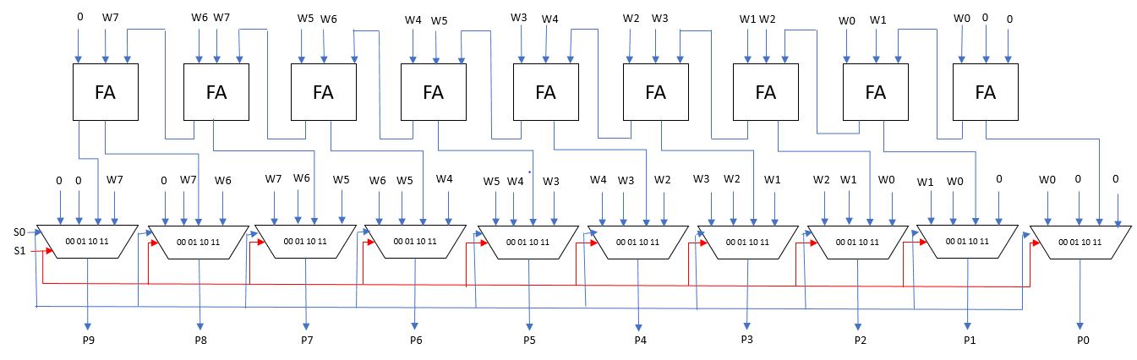
Figure 1 The schematic for the Mini-Multiplier which was created for mini project #6 and is implemented in mini project #7. The right most 8 Full Adders comprise an 8-bit ripple carry adder. The right most 8 multiplexers form an 8-bit vectorized 4 to 1 multiplexer.
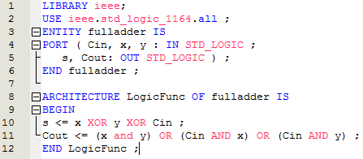
Figure 2 The VHDL code for a Full Adder.
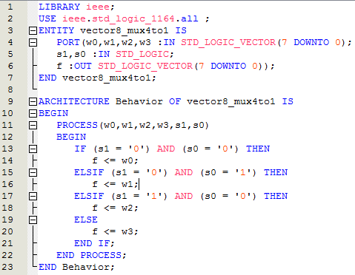
Figure 3 The VHDL code for the 8-bit vectorized 4 to 1 multiplexer. This code was provided by Dr. Hutson in the project description.

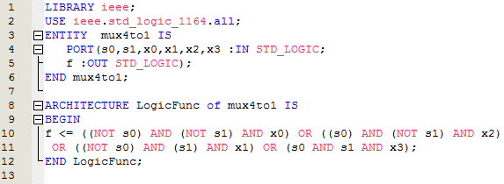
Figure 4 The VHDL code for a 4 to 1 multiplexer.
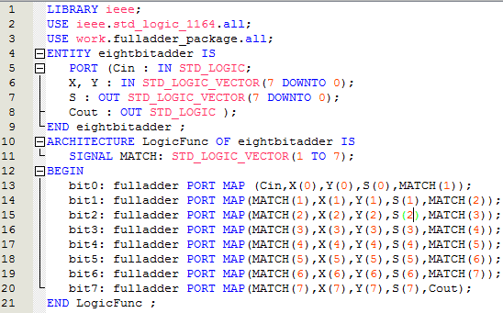
Figure 5 VHDL code for 8-bit ripple carry adder which is made up of 8 Full Adders.
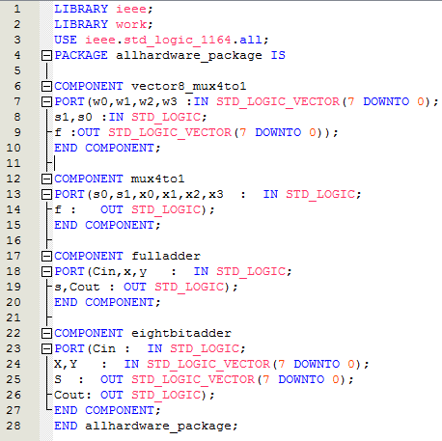
Figure 6 VHDL package file containing all the hardware files used to create the Mini-Multiplier.
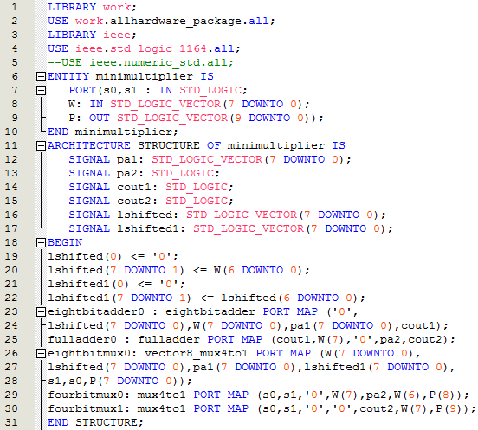
Figure 7 The VHDL code for the Mini-Multiplier which uses an 8-bit ripple carry adder, two 4 to 1 multiplexers, one Full Adder, and one 8-bit vectorized 4 to 1 multiplexer. Because of the way the inputs were wired, there was no need for bit shifters to be added. The signal lshifted and lshifted1 account for the one bit left shifted original input vector and the two bit left shifted vector. The signal pa1 is used as the output of the 8-bit ripple carry adder that feeds into the 8-bit vectorized multiplexer. The signal pa2 is the output of the lone Full Adder that feeds into the right-most lone multiplexer. The signal cout1 is the carry out of the 8-bit ripple carry adder that feeds into the lone Full Adder. The signal cout2 is the carry out of the lone Full Adder which feeds into the left most lone Full Adder. The circuit is controlled by the multiplexer pins s0 and s1 which select whether to multiply the 8 bit binary input W by 1, 2, 3 or 4. The 10 bit output of the multiplication is P.

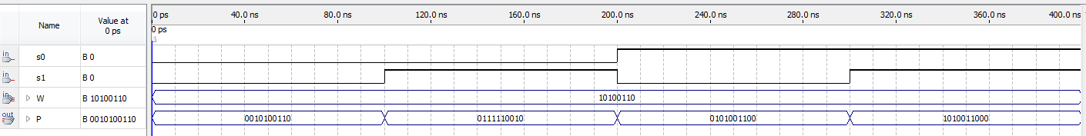
Figure 8 Functional simulation of the Mini-Multiplier circuit with the input W=10100110. When s0=s1=0 the circuit multiplies by 1 so the output merely has two extra bit places on the right that are zero. When s0=0 and s1=1 the circuit multiplies by 3 therefore the output is shown to be P=0111110010 which is correct. A multiplication by 2 is merely one left shift and a multiplication by 4 is two left shifts. When s0=1 and s1=0 the circuit multiplies by 2 which is correctly displayed as one left shift. When s0=1 and s1=1 the circuit multiplies by 4 which is correctly displayed as two left shifts.
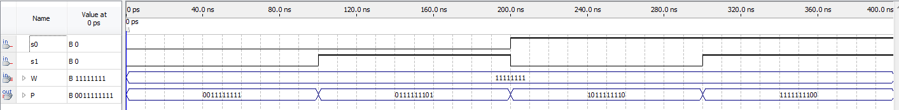
Figure 9 With the input W= 11111111 both the times 1 and times 4 multiplications work correctly, however the 2 most significant bits of the times 3 and times 2 are flip flopped for some odd reason. I have tried to debug my code for hours but I cannot find the problem. I checked both multiplexers that control the most significant bit places and the inputs coming into those multiplexers but I cannot find the problem.
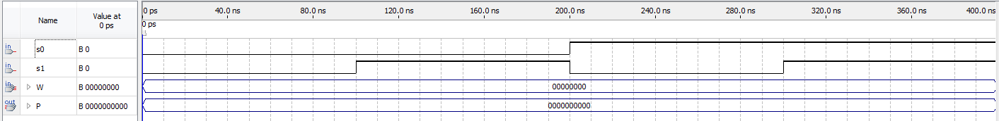
Figure 10 This test case shows correctly that any number times the input of zero will output zero.

